Local Authorities
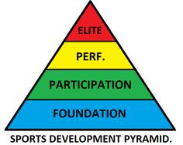
- Sport Development
Sports Development Teams aim to provide high quality opportunities at all levels, promoting sport as an activity that enables individuals to develop their own performances to their maximum potential, whist highlighting the personal and social benefits of a healthy lifestyle. This agency is concerned with increasing sporting opportunities for all members within their local authority and providing a pathway from participation to performance in addition with supporting the development of local clubs.
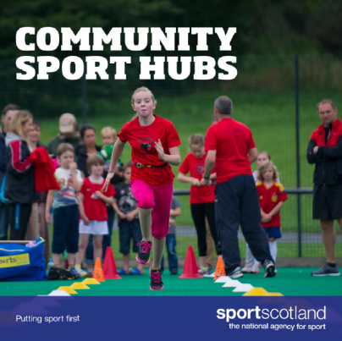
Community Sport Hubs
Through working in partnership with Local authorities’ leisure trusts, Sportscotland have been successful in setting up over 150 Community Sport Hubs (CSH) across Scotland with plans of more to follow. CSH for badminton clubs can be very useful as it allows sports clubs to get together and share ideas and resources. With this model in place clubs can feel part of a single wider community opposed to feeling isolated and alone. Furthermore, CSHs highlight the similarity between clubs that offer not necessarily the same sports.

CSH operate and function based on 5 key principles:

- Growth in participation
- Engage the local community
- Promote community leadership
- Offer a range of sporting opportunities
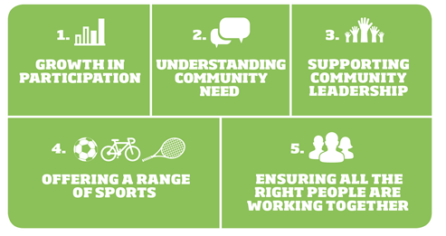
- Bring all appropriate (key) partners/groups/people together
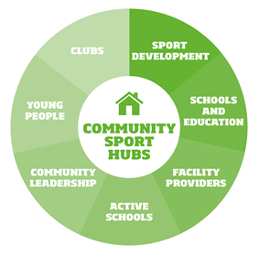

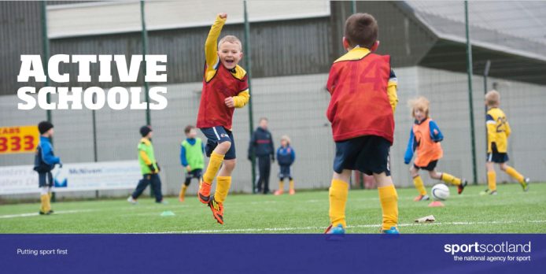
- Active Schools
Active Schools aims to provide more and higher quality opportunities to take part in sport and physical activity before school, during lunchtime and after school, and to develop effective pathways between schools and sports clubs in the local community.
Active Schools coordinators also have a key role in developing a network of volunteers
to deliver activity sessions. These volunteers consist of teachers, parents, school staff,
students, sports coaches and senior pupils who are central to the success of Active
Schools. Young people make a valuable contribution as leaders in sport and Active Schools
coordinators provide leadership opportunities across a range of roles and support
young people throughout their leadership journey.
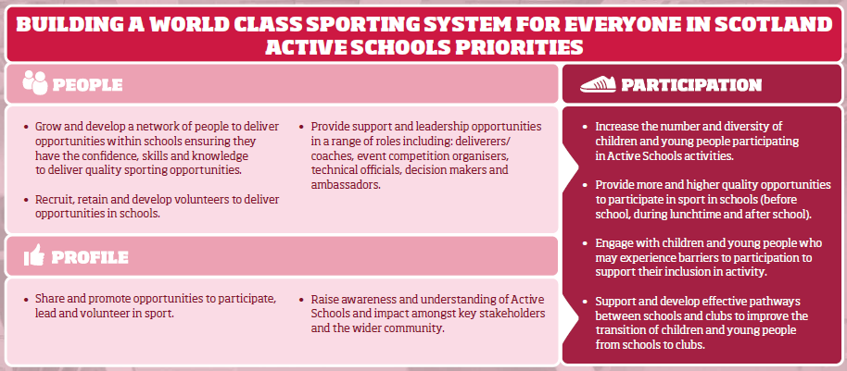
The aim Active Schools network includes to:
- Provide quality, safe and fun physical activity opportunities, including sport, both within the formal and informal curriculum
- Provide adequate resources and funding for physical activity and sport
- Actively promote positive attitudes towards participation in physical activity with pupils, teachers and families
- Ensure physical activity and sport is referenced within the School Development plan
- Encourage and support pupils to reach their full potential through physical activity, sport and physical education.

