Club Development Plan (CDP) Process

Where have we come from?
This section involves a self-reflection exercise on the club, so when it was formed, purpose or reason for its existence, what the club has achieved and state the progress the club has made up until the present moment. You may want to include a vision or mission statement in this section as well as a breakdown of the club’s aims and objectives.

Where are we now?
Before you forecast the future direction of your club you have establish the current position of the club. This can be achieved through conducting a SWOT analysis– highlighting strengths, weaknesses, opportunities and threats. In addition, it allows clubs to maximise the chance of developing their clubs’ talent, abilities and opportunities. *INCLUDE as part of AUDIT:
- Sustainability Review - statistics on membership, revenue and club attendance (weekly, monthly, quarterly review)
Check out sportscotland’s Club & Communities Framework as a guide: https://sportscotland.org.uk/media/4828/clubs-and-communities-framework.pdf
DEVELOPMENT AREAS (Examples)

Club Affiliation, Club Insurance, Club Accreditation, Governance, Club Identity, Committee, Coach, Volunteer Development, Facilities, Equipment | Constitution, Legal Structure, Club Bank Account, CWP Policy, Equality Policy, H&S Policy, Risk Assessment/Coach Session Registers, First Aiders, PVG, Code of Conduct, Data Protection Policy, Club Membership Form, Complaints Management Procedure, | Market Segmentation, Targeting, Positioning, Facebook, Twitter, YouTube, Official Club Website, Leafleting, Posters, Banner Stands, Local Press, NGB promotion, LA Leisure Trust promotion | School, Education, Active Schools, Sport Development, NGB, Local Charities, Local Businesses, Club Partnerships, National Group Committees, Badminton Development Associations, SSBU, Schools Area Group, Local Volunteers, College, University, | Club Development Plan, Sustainability, Funding, Fundraising, Sponsorship, Talent ID/Open Days, LTAD, Periodisation, Player/Performance Pathway, Supporting Services, Competition, Tournament, Leagues, Club Awards, Club Championships, Inclusive Strategy, Social Outings, Training Camps, Club Ambassadors, Feedback Forms, Club Session Evaluations, Mega/Major Sporting Event Engagement

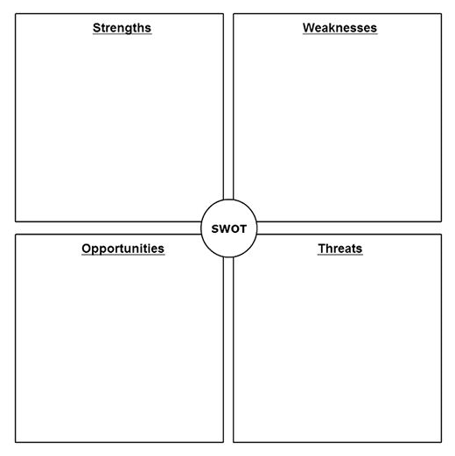

Where do we want to be?
Aims
Once you have analysed where you are at, it is important to now consider where you want to be and establish your aims for the future. Using the SMART (Specific, Measurable, Agreed, Realistic, Timed) goal setting framework this will assist clubs in the design of short, medium and long term goals.
- Specific - in relation to the club
- Measurable – being able to evaluate whether goal has been achieved
- Agreed – between committee, coaches and volunteers
- Realistic – goal is achievable and likely to produce effective outcome
- Timed – timescale of how and when (process and outcome) goals to be achieve

S | Specific | - What do club want to achieve?  - Why does club want to achieve this?  - What are requirements?  - What are the constraints?
M | Measurable | - How will progress be measured?  - How will club know when club has accomplished the goal?
A | Agreed | - How can the goal be achieved?  - Part of the process towards the goal, what are the steps that need to be taken?
R | Realistic | - Is it worthwhile goal for club?  - Is it the right time for goal to be set?  - Do I have the necessary resources to accomplish this goal?  - Is this goal in line with club’s objectives?
T | Timed | - How long will it take to accomplish goal?  (Short [1-3]/Medium [3-6]/Long [6-12])  - When is completion of goal due?  - When is the goal going to be worked on? (how much time dedicated to single goal)

Once you have recognized the club’s aims, the plan will set out the manner in which you will achieve them however first they need to be prioritised usually over a one, three or five-year period. Deciding on how your aims will be prioritised, this may depend on the simplicity of the task or perhaps the financial cost of achievement. Remember, aims must be realistic in terms of timescale and cost.

- Create 3-year Club Development Plan (see example)
- Create Year One Annual Plan (see example)

 | WHAT  What you want to achieve? | HOW  How will it be achieved? | WHEN  When will it be achieved by? | WHO  Who is going to do it? | COST  What will it cost in terms of time, people and money?
1) | e.g. Upskill all 3 coaches through NGB Coach Education qualifications | Attendance of Coaches at BB Award, UKCC 1 Award and Level 1+ Award. Contact BS to find out course dates. | March 2020 | Coach & Volunteer Coordinator | Time of contacting Badminton Scotland and submitting applications. Total amount is £300 (club will subsidise 50% of fees). Includes 30 hours of time between 3 coaches
2)
3)
4)
5)
Once the action plan is agreed it is a working document that should be reviewed and updated regularly to ensure progress is being made and targets met. It should be modified to take account of changes in personnel, unforeseen delays, funding issues etc. A report should be made at the monthly committee meeting with regards to progress and to acknowledge the work of the volunteers involved.

 | GOAL | STATUS  (RED – incomplete; AMBER – in progress; GREEN – complete) | DATE OF REPORTING | NOTES
1) | Upskill all 3 coaches through NGB Coach Education qualifications |  | September 2020 | Application for BB Award submitted

