Membership Incentive Scheme
When it comes to clubs aiming to develop their membership, decision-making should be based around questions such as:
- Why people join your club?
- Why people continue to play at club?
- Why do people leave your club?
The outcomes from these questions tend to shape the future or long term running of your club in relation to coaching services, financial forecasting and overall club promotion.
One strategy to attempt to sustain membership is to introduce a Membership Incentive Scheme. Below are some examples:

1) Bring a Friend’ Campaign
This would allow current junior members to bring a friend or friends along free of charge or at a discounted rate (Friend gets 50% off first lesson). It is up to the club how strict a criteria they want to set i.e. cap at maximum of 3 friends.
2) 50% off First Session
This scheme suits new starts club or existing clubs who perhaps are looking to increase their membership. Halving the price of an initial session is an attractive offer and demonstrates how clubs are flexible in their methods towards recruiting new members.
3) Attend 6 sessions and get next session free!
This is a reward system where member’s attendance and loyalty to their club is recognised. This highlights the fact that clubs are willing to value the commitment of their members. Many clubs adopt a token system and introduce prizes—just remember to add this into your costings! This option might not be feasible for some clubs.

Example: Tesco Club card Points
Tesco Clubcard is the loyalty card system that used in the UK and across Europe.
It was introduced back in 1994 and has progressed from a card to a car key fob. As of 2010, the scheme has 15 million members on it.
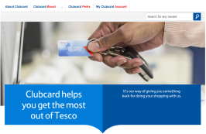
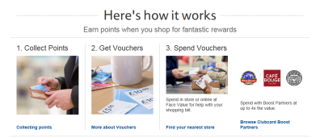
Members of the scheme receive 1 point for every £1 they spend. It has evolved into rewards on savings such as fuel through Clubcard Fuel Save.

