Coach & Volunteer CPD
For this requirement, clubs must submit evidence showing they have completed the following:
- FIRST AID: 1x Coach holding an active First Aid Qualification (accredited by UK Government Health & Safety Executive) (renewed every 3 years)
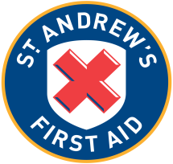
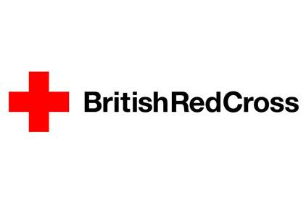

- CHILD/ADULT WELLBEING & PROTECTION IN SPORT: Child Wellbeing & Protection Officer has completed sportscotland Children 1st Child Wellbeing & Protection Officer (CWPO) Training (formerly sportscoachUK In Safe Hands Level 2) Workshop (every 3 years)
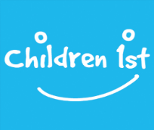

- COACH, CLUB & VOLUNTEER: Attend 2x CPD Workshops per year. This can include any of the following:
    - Badminton Scotland – National Coaching Conference (Grand Prix), Club Development Workshops or Coach CPD Workshops (includes Pathway Club Workshops)
    - Sportscotland – Coach Connect or Coaching Talent Workshops
    - Local Authority – This can include any courses/workshops run/delivered by Local Authority (Council/Leisure Trust)
    - Other – submit any other types of CPD your club completes for review

