Club Promotion

## [fb_icon_325x325](https://www.google.co.uk/url?sa=i&rct=j&q=&esrc=s&source=images&cd=&cad=rja&uact=8&ved=0ahUKEwj71vTStonMAhUDxxQKHeLwBxMQjRwIBw&url=https://en-gb.facebook.com/&psig=AFQjCNHhIqze8V_ejKqp2pWErP_61u04MQ&ust=1460561619605325)1. Social Media

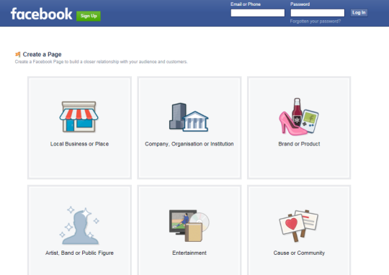

**1.1 Facebook**

For Badminton Clubs, Facebook can be a great tool in marketing and promotion of a club as well as effective way for clubs communicating with its current members. Also due to its ever increasing popularity with 1.59 billion users globally, Facebook can be very effective when attempting to reach your target markets.

[](http://www.google.co.uk/url?sa=i&rct=j&q=&esrc=s&source=images&cd=&cad=rja&uact=8&ved=0ahUKEwjP27edno7MAhWF6RQKHYIoBYIQjRwIBw&url=http://thenextweb.com/insider/2015/06/24/facebook-messenger-can-now-be-used-without-a-facebook-account/&ps)It is recommended that you create the following on Facebook for your club:

> A **group/business page** that is used to post pictures and updates on club achievements and other information and is open to the public to access and view.

> A **closed group page** that will be hidden and only accessible for members on Facebook by invite. This can allow club’s to discuss more private issues and allow a conversational feel to posting on the page—members can post stating they are available/unavailable for club session or events.

When using Facebook to promote your club, there are issues surrounding child protection and sports clubs using online social media. It is recommended to check out Badminton Scotland’s policy on coaches and club members using social media for guidance*.* Benefits of a Facebook Page include:

> It’s quick to set up and a club page can be easily customized with your logo, club colours, etc.

> Facebook users (including existing and potential members and volunteers) can easily find key information and contact details for your club.

> Creates conversation about your club, promotes events and updates members and fans.

> Allows your club to be easily found in search engines, such as ‘google’.

[](https://www.google.co.uk/url?sa=i&rct=j&q=&esrc=s&source=images&cd=&cad=rja&uact=8&ved=0ahUKEwjYqaCJzZDMAhXDSBQKHbFBDeMQjRwIBw&url=https://play.google.com/store/apps/details?id%3Dcom.twitter.android&psig=AFQjCNGr2bGV5JKG_HiYkIVtfOejDFwrSA&u)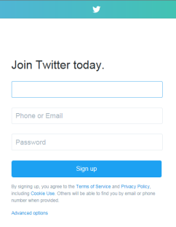 **1.2 Twitter**

With 60% of people in the UK using social media, this suggests that the likes of Facebook are going to be around in the future. Twitter is also a very effective way of communicating with the public. Currently there are estimated 270 million twitter users and approximately 500 million tweets being sent per day.

For badminton clubs, it is important to identify exactly what Twitter can offer in terms of value. It has many positives where you can give updates on live scores or results and perhaps allow feedback on issues regarding you club. There are 4 steps that you can follow to setup a Twitter Account:

**> STEP 1:** Setup Twitter Account. Go to [www.twitter.com](http://www.twitter.com). You will have to fill out Full Name, Email Address or Phone Number and create a Password.

**> STEP 2:** Aim to be followed and follow others—see diagram to left (to follow another person or organisation profile click *‘follow’) [CIRCLED IN RED]*

**> STEP 3:** To show interest or connect to others you can click Retweet or Like a Twitter post.

Also if you want certain people to see your tweet you can include:

There twitter name ‘@..........’. If you put this at beginning of tweet they can only see tweet and it can then be more of conversation between two accounts. On the other hand, as demonstrated in example above if you insert ‘@........ ’ anywhere in the tweet, it can then be viewed by the public.

**> STEP 4:** The use of hashtags (#). Hashtags are often used on Twitter when people want to highlight an event or topic that may be of interest. When someone clicks on a hashtag or searches for them, all of the tweets using the particular hashtag will appear.

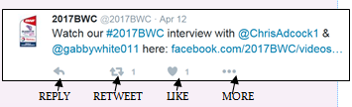

[](http://www.google.co.uk/url?sa=i&rct=j&q=&esrc=s&source=images&cd=&cad=rja&uact=8&ved=0ahUKEwjG3If06ZDMAhVDtRoKHb6aB1MQjRwIBw&url=http://alexnoudelman.com/top-10-youtube-viewing-countries/&psig=AFQjCNGzLLZU01GLOCXywcmGLl5eU9An_Q&ust=14608160117)**1.3 YouTube**

YouTube is an online phenomenon with around 4 billion videos watched per day. It is video sharing website and the 2nd largest search engine behind google with 100 hours of video uploaded every 60 seconds. This makes it an attractive platform for organisations to use to advertise and promote themselves—with many sports clubs using it showcase their talent and achievements. Best of all it is free of charge!

Before you begin to create a YouTube account, you must have two things: videos you can upload and a logo for your club. Below is a step-to-step guide of how to create the ideal account for your club:

> STEP 1: Go to [www.youtube.com](http://www.youtube.com)

> STEP 2: Click on *’Sign in’* button. You will then be asked if you wish login or below it will have link for *’Create Account’*

> STEP 3: Once logged in you should be redirected back on to the

YouTube homepage. To upload a video click on

‘Upload’. You will be directed to this page with

options to upload a video.

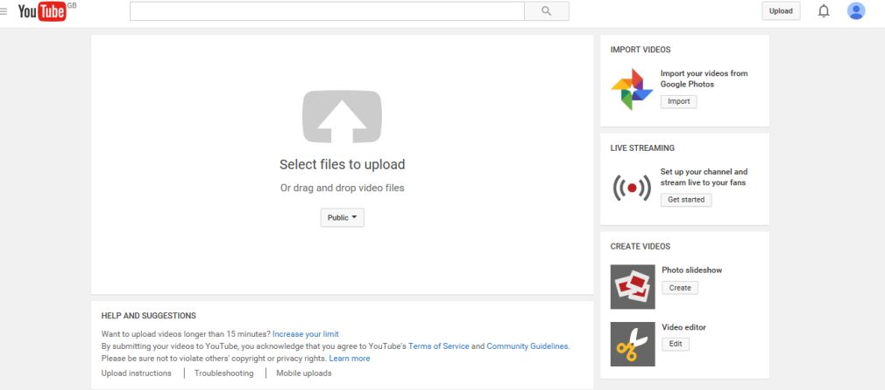

[](http://www.google.co.uk/url?sa=i&rct=j&q=&esrc=s&source=images&cd=&cad=rja&uact=8&ved=0ahUKEwiZzsiYyrDUAhVB2xoKHW3RAgwQjRwIBw&url=http://www.isn-amsterdam.nl/instagram&psig=AFQjCNG67X0n8PbHlSFcEVC41Avla198pQ&ust=1497090608348130)

**1.4 Instagram**

Instagram (<https://www.instagram.com> ) is a social networking app made for sharing photos and videos from a smartphone.

Similar to Facebook or Twitter, everyone who creates an Instagram account has a profile and a news feed.

When you post a photo or video on Instagram, it will be displayed on your profile. Other users who follow you will see your posts in their own feed. Likewise, you'll see posts from other users who you choose to follow.

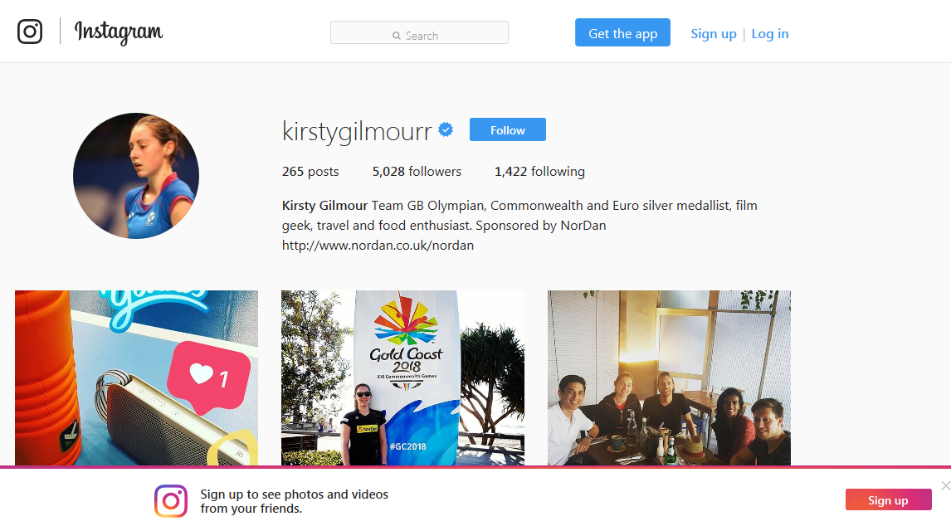It's like a simplified version of Facebook, with an emphasis on mobile use and visual sharing. Just like other social networks, you can interact with other users on Instagram by following them, being followed by them, commenting, liking, tagging and private messaging. You can even save the photos you see on Instagram.

Benefits of using Instagram:

* Free Advertising
* Most popular Social Media platform in comparison with Facebook and Twitter
* Effective in reaching target audience - did you know that 37% of users are born between 1980s and early 1990s
* High levels of engagement – it was measured that Instagram content generates on average 58 times more engagement per follower than Facebook and 120 times more than Twitter
* Create feeling of trust and loyalty with users towards your brand

## C:\Users\Euan\AppData\Local\Microsoft\Windows\Temporary Internet Files\Content.IE5\4GX22313\shutterstock_122664076[1].jpg2. Websites

Having a club website can be useful as a way of communicating with members and aiming to increase profile of club with aim of growing club membership. The purpose of a website is to provide informative or practical information that is helpful to a specific user i.e. members and people interested in badminton or have desire to join a badminton club. When creating a website, it is up to you how you want it to look and what pages you would like to include:

**> Homepage**

Brief description/statement about club - ‘*’Scotland’s Number 1 Badminton Club!!’’*

**> About Us**

History of club, when it was established. Mention vision and objectives of club and overall ethos.

**> What do we offer**

Coaching sessions for all ages or junior/adult only? This section should inform reader of coaching classes available and where sessions are based**.**

**> Contact Us**

Should contain contact address, email, phone number and link to club’s social media

**> Testimonials**

From parents, sport development professionals, the national governing body, local people, club members

**> Photo Gallery**

Photos from events or competitions club took part in.

**> News**

Keep members up to date about club achievements or important announcements regarding club

**> Meet the Team**

Information on committee and the coaches

**> Competition**

Event Calendar of important dates for your club regarding fixtures or tournaments

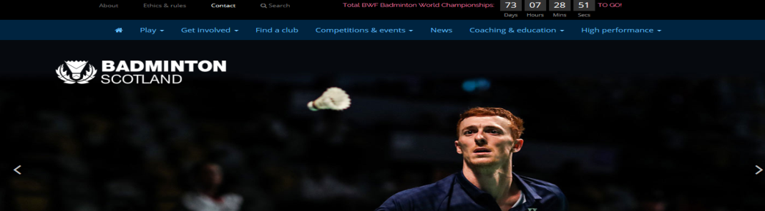

## [News-837x600](https://www.google.co.uk/url?sa=i&rct=j&q=&esrc=s&source=images&cd=&cad=rja&uact=8&ved=0ahUKEwie693y4qLOAhVCWRoKHUT6Ar4QjRwIBw&url=https://pancreaticcanceraction.org/news/template-press-release-for-petition/&bvm=bv.128617741,d.ZGg&psig=AFQjCN)3. Local Press

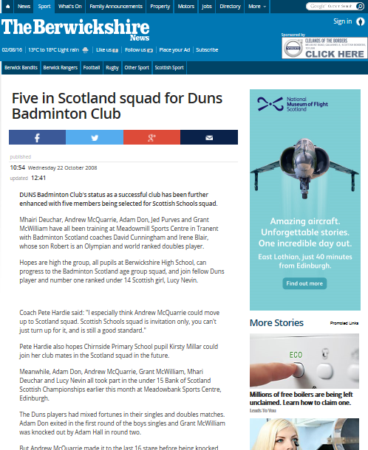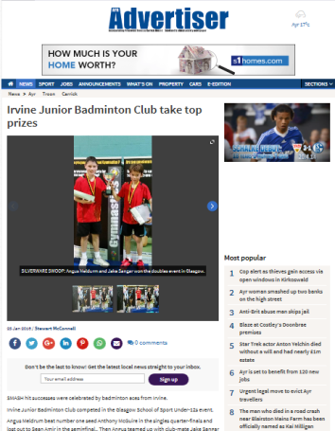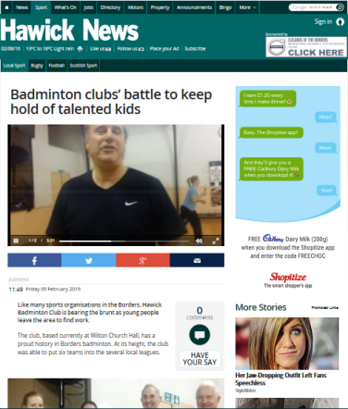 With the gradual shift from traditional paper press to online media press, local press can still be an effective way of promoting your local badminton club. Local press refers to coverage of events and news with in a local context that may not be of interest to people in other communities. For example, would a person living in the Southside of Glasgow be as interested in a local news with in Northern area of Edinburgh? This type of advertisement for clubs has many positives:

•  **Target Audience:** With football typically dominating sports sections with in local press, badminton clubs have a great opportunity to reach a proactive audience who are interested in sport and are attracted by uniqueness of a story on a minority sport

•  **Positive Image:** Clubs who have articles in local paper are generally portrayed positively with in local community as website pop-ups can be seen as being intrusive. Having an advertisement or press release suggests that clubs are open and well connected to the community

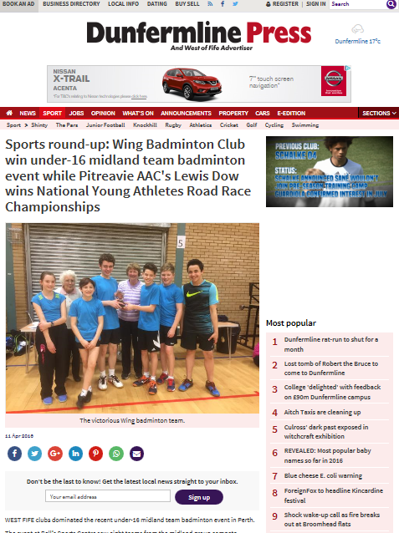•  **Trusted Information:** Local Press aim to develop positive relationships with the community and are more likely to endorse local badminton clubs knowing that they are not untrustworthy. This means that readers are likely to believe that they are reading accurate information.

•  **Supporting local journalism:** With the decline of print media especially at a local/regional level. Clubs who use local press for articles and advertisement are recognised as doing good for the community by looking to engage local people in sport. Many press companies now operate online and is worthwhile for clubs to investigate into possible opportunities for advertisement

•  **Convenience and flexibility:** Press companies offer wide array of options when comes to advertising your club. This includes small 1-inch square classified ads, column ads, press release (club promotion), and an information article (e.g.. local badminton coach providing coaching tips).

## 4. Leaflet, Posters and Banner Stands

This section of marketing involves the art or skill of combining text and images to create advertisements. Generally, clubs will use the same design for leaflets, posters and banner stands in order for a consistency in brand identity to be established. There are few questions to be answered when planning marketing strategy – where are best places to situate posters, distribute flyers or put up banners stands?

When designing an effective flyer here are 15 top tips:

1. Title has to be attention-grabbing and catchy! Consider alliteration/rhyming words or trigger words

2. Identify a main theme or message: are the benefits of your club clear?

3. State what you have to offer in a short and snappy manner

4. Draw up a strategy to promote your leaflet : who will you send them to, which area will you do the leaflet drop, leave them in local businesses, upload leaflet to your Facebook page or social media page, always consider your target market when drawing up a strategy (consider results from marketing segmentation questionnaire)

5. Highlight your club’s unique selling point: what you do better or differently to other clubs or what can you offer that no other club can

6. Ensure good professional design of the leaflet

7. Be clear and concise: Don’t write too much information and use words of excitement to draw the customer in

8. Provide an incentive—is there a club membership loyalty scheme or joining incentive (50% off or free 1st session)

9. Ensure your design conveys a positive message ‘I do, I can’

10. Put your contact details on the leaflet e.g. Number, website, email, Facebook page

11. Include Images: this includes logo, club members, and sessions. Images can say more than words and may attract more members into joining

12. Have a call to action: log onto club website or social media page, and receive 10% discount or free club merchandise. Common tactic used in marketing and advertisement

13. Check all spelling is correct; if necessary get someone else to check it.

14. Good quality print always makes the difference.

[](http://www.google.co.uk/url?sa=i&rct=j&q=&esrc=s&source=images&cd=&cad=rja&uact=8&ved=0ahUKEwjR4u7m947OAhXCtBoKHbf9BuoQjRwIBw&url=http://www.123rf.com/stock-photo/display_stand.html&psig=AFQjCNFDsq_g5T0LhzSExX5KBzHkVCVt1Q&ust=1469547115887382)15. Readable font size is essential: no less than 10. Make heading bold as that should be main draw of design.

