Bronze Club Coach

(Badminton Basics Coaching Award)

Badminton Scotland Badminton Basics Award Certificate for Coaches in Badminton

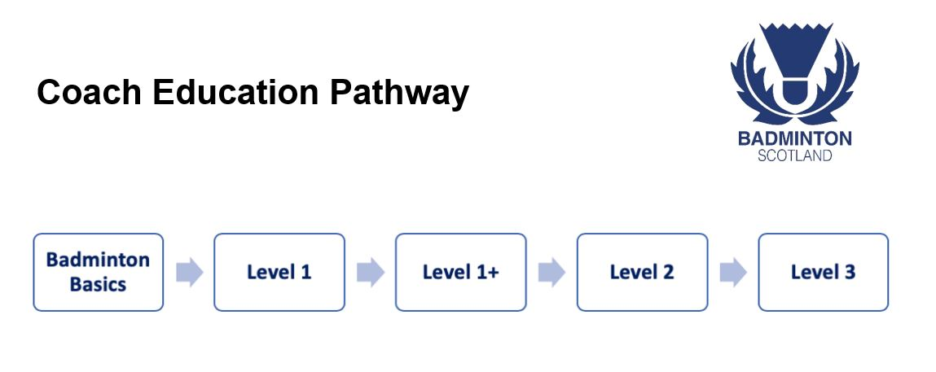

What does it qualify you to do?
The Badminton Basics Award (BBA) course is the entry point on to the Badminton Scotland Coach Education Pathway and qualifies you to lead at Smash in2 Badminton sessions or assist UKCC Level 1 coach at Club Sessions.

What are the course learning outcomes?
By the end of the BBA candidates will be able to:
- Setup simple and fun games
- Able to run activities safely and efficiently with large numbers in limited space
- Adapt activities using to challenge players or simplify activities
- Understand the key skills that are developed through BBA activities and practices:
  - Agility/Flexibility
  - Balance
  - Co-ordination
  - Speed
  - Endurance
  - Social Interaction
- Understand basic rules for Singles and Doubles games
- Understand the how to plan a fun session for beginners
- Understand the racquet grips required for badminton
- Understand how to teach low backhand serve and high forehand serve
- Understand how to teach basic technique for an overhead stroke
- Introduce basic hitting practices progressing to rallying in groups of 2/3/4

How long does it take to complete?
The BBA course is a 1 day course that lasts for 6 hours.

Are there any pre-requisites?
There is not any explicit pre-requisites however having some experience in coaching sport or playing badminton will help
The minimum age is 14.

How much does the course cost?
£40 per candidate (Affiliated Club/Individual/Coach/School Member)
£50 per candidate (Affiliated Smash in2/Supporter Member)
£55 per candidate (Non Member)

