Silver Club Coach (Level 1+)

Badminton Scotland Level 1+ Certificate for Coaches in Badminton

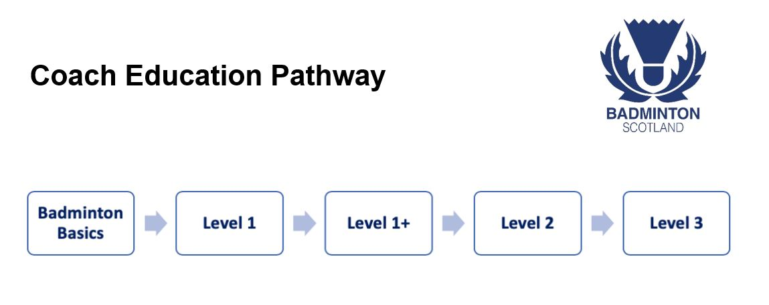

What does it qualify you to do?
The Level 1+ qualifies the coach to plan, lead and review sessions for beginners and intermediate players.

What are the course learning outcomes?
By the end of the Level 1+ Certificate, Coaches will:
- Understand the role and responsibilities of the coach and how to structure a session
- Develop appropriate progressive practices
- Understand tactical play and include in progressive sessions
- Accurately fault correct with specific feedback for improvement
- Plan, Deliver & Review a badminton coaching sessions

How long does it take to complete?
The Level 1+ Certificate for Coaches in Badminton is a one day course including on course assessment.

Are there any pre-requisites?
Candidates will be required to complete the UKCC Level 1 before attending Level 1+.

Is there any pre-course or work required to be completed away from the course?
Prior to the course, learners are expected to read over UKCC level 1 booklet to refresh ‘How to Coach’ Skills.

How has our Level 1+ been developed?
It has been recognized that progressing from UKCC Level 1 to UKCC Level 2 can be difficult due to the intensity, content and expectations at Level 2. This course has been developed to assist in the transition between UKCC Level 1 and UKCC Level 2 and to allow coaches who want to coach beginners and intermediate level players, the opportunity to become a stand-alone coach. Our Level 1+ course has been developed by our Badminton Scotland steering group, consisting of a tutor representative, a coaching representative and a performance representative.

How much does the course cost?
Badmintonscotland Level 1+ Certificate for Coaches in Badminton:
Coaches not on Coach Register - £130
Coaches on Coach Register - £100

How do you find a course & apply?
We are currently in the process of scheduling UKCC Level 1+ courses. Please contact lynn@badmintonscotland.org.uk if you would like to be contacted when we have dates confirmed.

Require more information?
Please contact the Engagement team for more information on the Level 1+ Certificate for Coaches in Badminton.
Phone: 0141 445 1218
Email: lynn@badmintonscotland.org.uk

