Gold Club Coach (Level 2)

Level 2 Certificate for Coaches in Badminton

What does it qualify you to do?
The Level 2 qualifies the coach to independently plan, lead and review coaching sessions and develop coaching programmes to support the development of players.
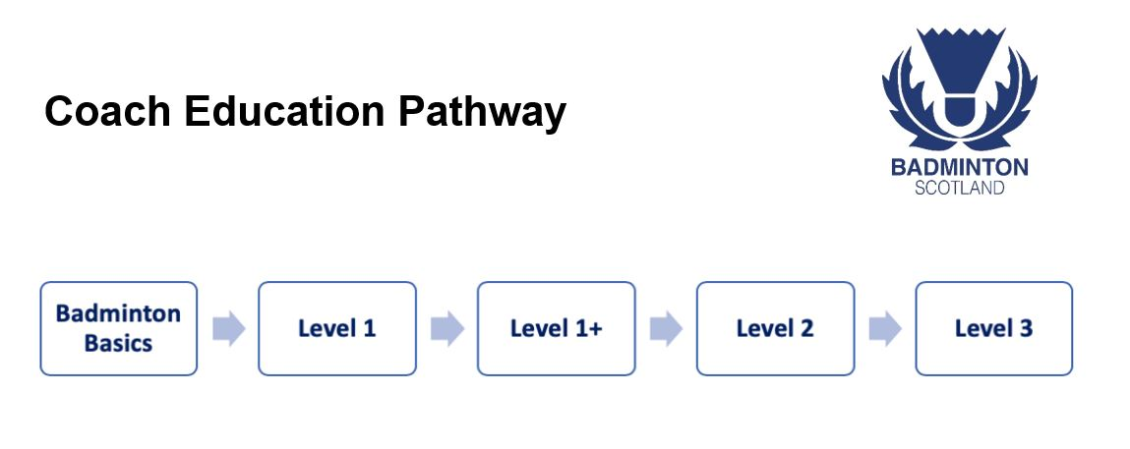
What are the course learning outcomes?
By the end of the Level 2 Certificate for Coaches in Badminton learners will be able to:
- Understand the role and responsibilities of the coach
- Apply the correct biomechanical principles of hitting technique and provide an accurate demonstration of defined badminton strokes
- Apply the correct biomechanical principles of movement to a wide range of movements performed in badminton
- Understand and apply key singles and doubles tactics, develop sets of progressive tactical practices to develop discipline-specific hitting and movement skills and effectively communicate with players tactically
- Recognise and interpret the significance of hydration and nutrition in badminton performance
- Apply knowledge of anatomy, physiology and kinesiology to badminton
- Recognise the mental processes required to cope with stresses in badminton
- Understand substance misuse in sport and badminton
- Plan, Deliver & Review a series of badminton coaching sessions
How long does it take to complete?
The Level 2 Certificate for Coaches in Badminton is three days taught learning followed by an assessment day usually delivered over a 2-3 month period.
Are there any pre-requisites?
Candidates will be required to complete the Level 1 and Level 1+ before attending Level 2.

Is there any pre-course or work required to be completed away from the course?
All Level 2 courses involve pre-course e-learning modules that are assessed. These e-learning modules include:
- Lifestyle & badminton
- Mental processed in badminton
- Physiology & badminton
Away from the course, learners are expected to develop and deliver two sets of linked progressive sessions, one for an individual and one for a group of players.

How has our Level 2 been developed?
Our Coaching Qualifications have been developed by a source group formed of members from a variety of backgrounds, including:
- Our Performance Team
- Our Tutor Workforce
- Members of the UK Source Group (Representatives from Badminton Scotland, Badminton Wales & Badminton England)
- SportsCoach UK
This source group has ensured that our Coaching Qualifications form a clear and defined coaching pathway that will shape and support coaches along their coaching journey giving them the relevant skills and experience at the right time.

What does UKCC endorsed mean?
The Coaching Qualifications we currently deliver as part of our coach education programme are endorsed by and sit on the Qualifications & Credit Framework. Across the three levels of the qualifications they aim to introduce and progress learner’s knowledge of technical and tactical elements of the game as well as the "art" and the "science" of coaching by introducing coaches to the “How to” skills of coaching.

How much does the course cost?
Level 2 Certificate for Coaches in Badminton:
Full cost of course - £365
After subsidy is deducted - £146
Sportscotland Subsidy
Candidates can access up to 70% off Level 2 courses. To apply for funding towards your qualification, please follow the link here:

How do you find a course & apply?
We are currently in the process of scheduling Level 2 courses. Please contact lynn@badmintonscotland.org.uk if you would like to be contacted when we have dates confirmed.

Require more information?
Please contact the Engagement team on 0141 445 1218 or email lynn@badmintonscotland.org.uk for more information on the UKCC Level 2 Certificate for Coaches in Badminton.

To find out more about our courses:
http://www.badmintonscotland.org.uk/coaching/coaching-course-dates/?summary=all

