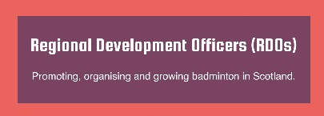

Highlands, Islands and Moray/North East (temporary) - July 2023
Summer Badminton Camps.
This month has seen a variety of work and activity that is makes the role of Regional Development Officer (RDO) for the Highlands, Islands and Moray/North East (HIM/NE) so interesting.
Badminton Moray (BM) have been busy delivering two Summer, Badminton Camps in the Area. One in Moray SC, Elgin and the other in Forres House Community Centre. These Camps were led by Angela Bell assisted by Caroline Mair and additional support in Forres from a member of the Badminton Moray Squad – Great to see young players giving back to the sport.

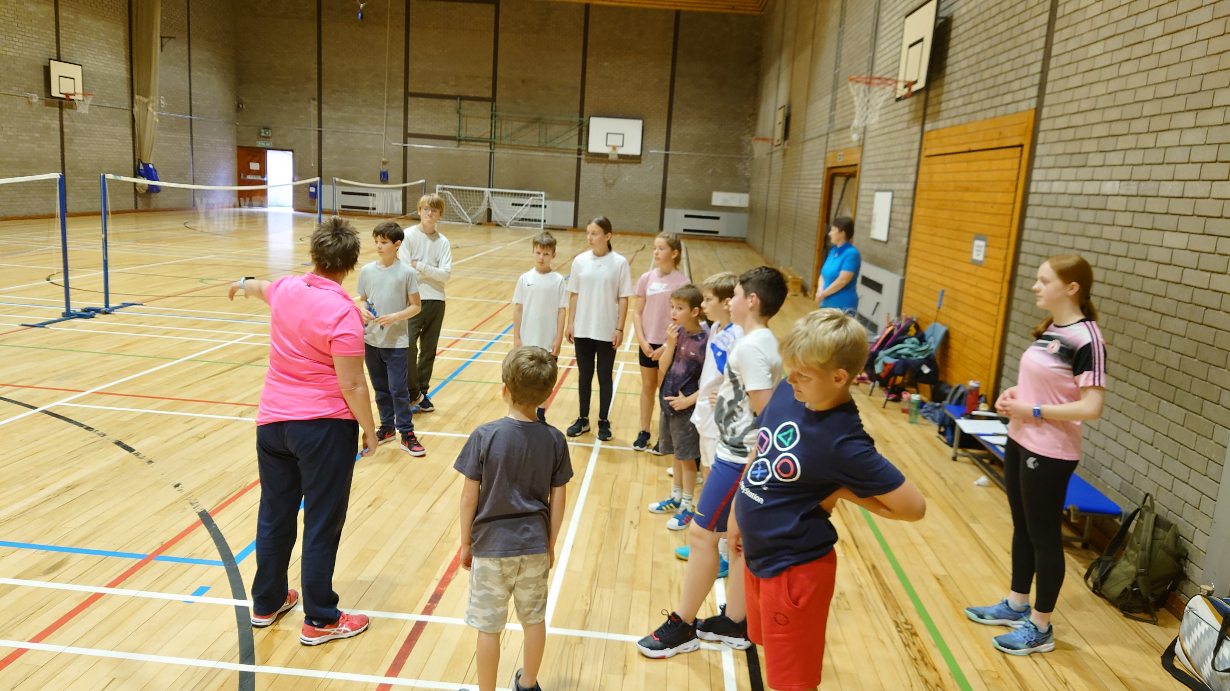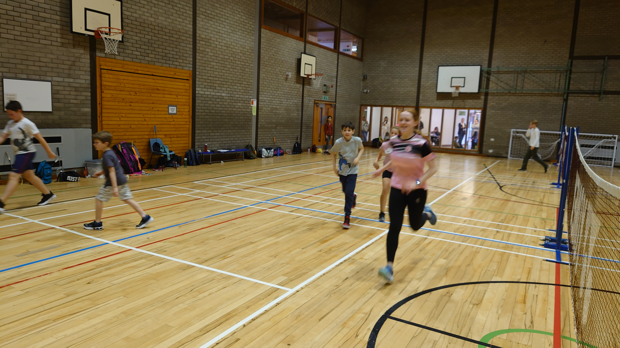
Both terrific venues, ideally suited for the delivery safe, fun, badminton activity where the participants learn in a positive environment, led by experienced and developing coaches in venues where parents can relax, enjoy a chat, a coffee, meet new people and relax whilst their children enjoy our sport. Because of these factors BM saw a 55% increase in attendance at the Forres Camp over the week.
Using social media to make contact with existing and new, Badminton friendly schools in the area, created links that will be followed up in the coming months.
Partner organisations such a High Life Highland and Nairn Sports Club are using the summer holiday to deliver Badminton Camps in Inverness and Nairn. The more time we have to introduce our sport to existing and new players during the close season creates more opportunities to engage with these organisations and work to create more badminton activity for players/families and then links to clubs in the locality.
Looking forward. The plans are to expand the Camp Calendar throughout the HIM Area through Clubs, Associations, Groups and our Key Partners.

Coach and Officials Education Calendar for HIM.
After arranging the delivery of three Badminton Basics Courses in Wick, Forres, Aberdeen and a Closed Course in Banchory between, May through to July, work continues to try develop a Coach Education Calendar that provides a list of available Formal Coach Education, Continuous Professional Development Courses, Player Development and Line Judging Courses in venues that are local to where people live.
In such a huge geographical area as the HIM/NE Area; Badminton Scotland are looking to deliver courses locally to ensure potential participant’s travel and accommodation costs do not preclude participation any Badminton Scotland led courses. Working with partner organisations such as Live Life Aberdeen-shire and Active Schools Officers, throughout the Area provides creative partnerships which embrace this philosophy and maximises participant numbers attending courses.
To produce an affective calendar for the area, all the following points need to come together at the same time – sometimes it feels like a tough ask;
- Facilities – Depending on the course we are looking to deliver and the time of year this can be a village/community hall; a secondary/community school hall to an eight court Badminton Centre designed for international competition. Working to find dates such facilities are available is difficult as many people who read this will know.
- Cost to hire the facility – Financial constraints are putting demands on facility providers to increase hire costs of courts and facilities which is having the effect, making some facilities not being available to hire due to these costs.
- Tutor availability – Linking tutors with possible dates that facilities are available for tutoring, takes considerable planning. Tutor recruitment – See below.
- When 1, 2 and 3 come together; we then make the course ready for publication and accepting bookings on the JustGo system, hand over the administration to Lynn Narey at HQ and it’s over to the local Badminton/sports community to support the courses.
Successful completion of this work relies on strong administration skills and hopefully the Tutors linked to the calendar will see an improvement in these skills over the coming months.
The Calendar for August ‘23 through to August ‘24 continues to evolve and take shape. Recent conversations have been held with Shetland, Orkney, Caithness Associations on making courses work in these areas.
- Tutor Recruitment
One of the learning outcomes from working on the Coach and Officials Education Calendar it has highlighted the undeniable fact that we need to recruit and provide training for more Tutors. It’s good to report that there are now several people who have made their interest in becoming a Coach Education Tutor known to us at Badminton Scotland. If you think you have the experience and would be interested in this rewarding role within Badminton Scotland, contact your RDO in the first instance and we will discuss the process with you.

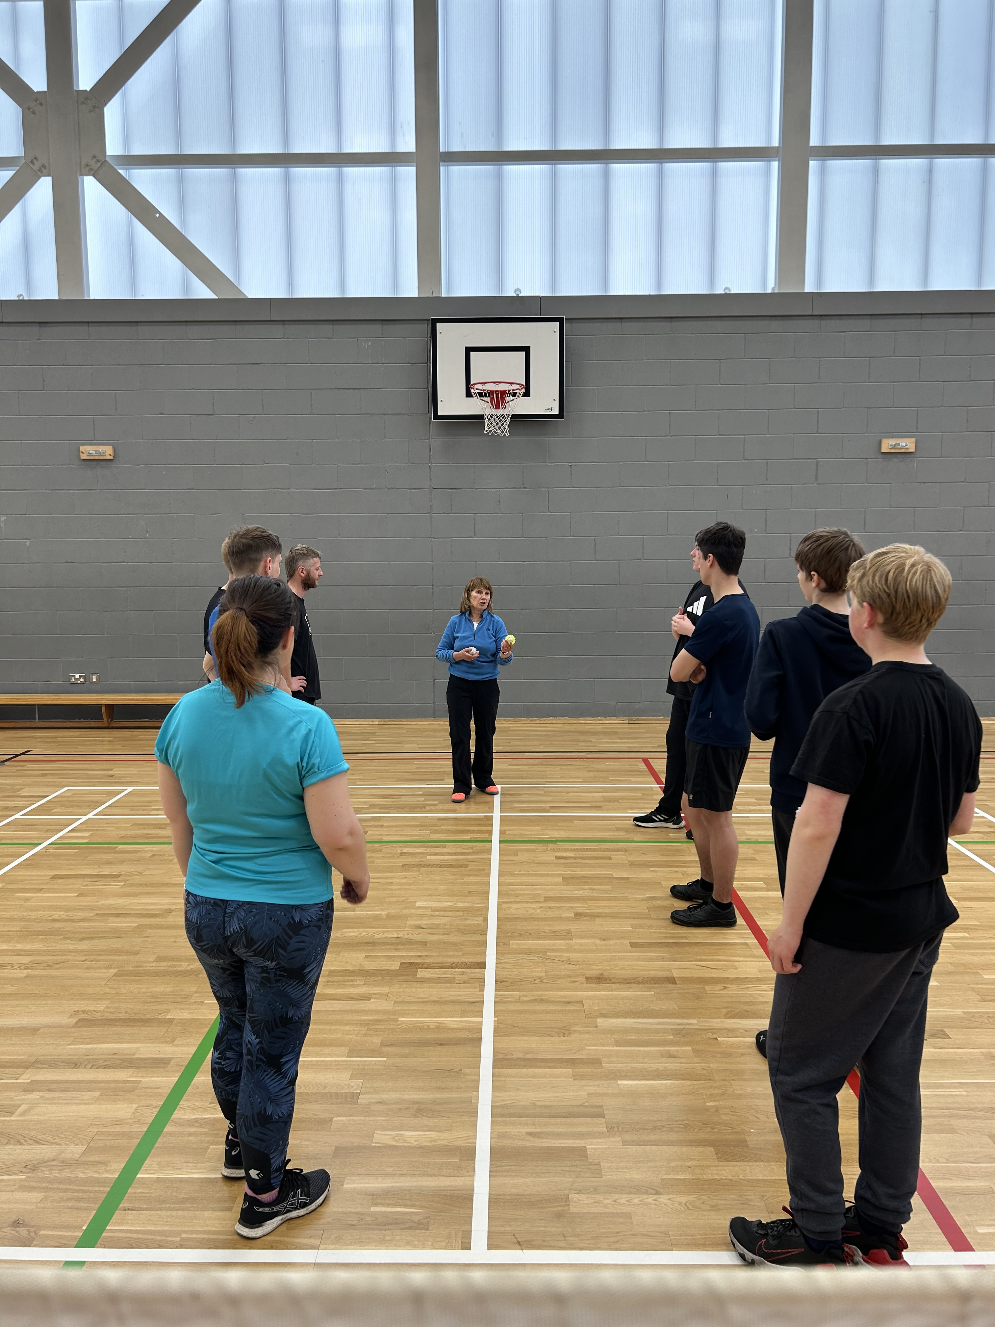 Coach Education Opportunities in the HIM/NE Area
- Badminton Basics – August 13th 2023 – Moray Sports Centre – Places available for people aged 14 years and older. Bookings being taken on the JustGo System
- Level One – September 2023 – Moray Sports Centre. In the final stages of planning. Participants MUST have attended a Welfare and Protection Course as a pre-requisite to participate.
BS Subsidies will apply. Contact Brian Donaldson on brian@badmintonscotland.ork.uk for more information.
- Level One Plus – October 2023 – Moray Sports Centre. In the final stages of planning. Contact Brian Donaldson on brian@badmintonscotland.ork.uk for more information and BS Subsidies will apply.
- Additional Courses will become available in Aberdeen-shire in partnership with Live Life Aberdeenshire

Shuttlemark Accreditation
It’s been great to be working with the Office Bearers representing Clubs, Associations and Groups on their Shuttlemark Accreditation.
The Shuttlemark Scheme allows Clubs to look at their organisation structures and how the office bearers engage with the membership in the day to day running/management of all club activity. As office bearers work through the process we will see clubs develop that are stronger, vibrant, dynamic, inspirational and inclusive; servicing the badminton needs of their local community/communities.
For more information on Shuttlemark and the Shuttlemark Inclusive Disability Charter go to the Badminton Scotland website or contact your local RDO.

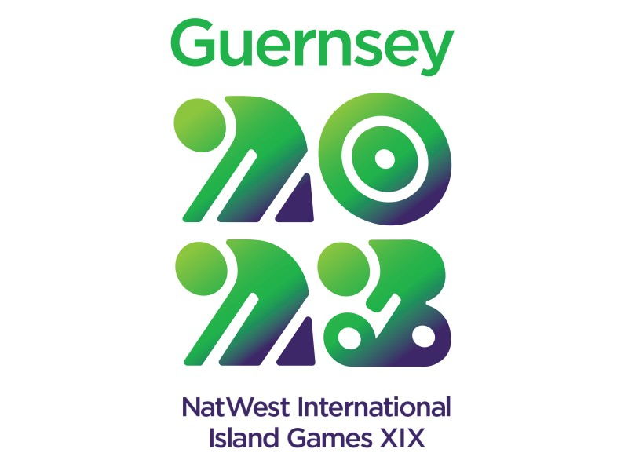 The Nat West International Island Games Island Games 2023

July also gave me the opportunity to take a busman’s holiday and travel to Guernsey to watch the Badminton Championships that were part of the Guernsey Island Games and to catch up with the team managers, players, coaches and families.
The visit provided the opportunity to learn, to reflect to bring back ideas and to share the experience with others within the HIM Badminton Community, Badminton Scotland and Sport Scotland. To look to how each Island Community wants to see our sport develop in their area. Some reflection has already begun
- The demonstration of teamwork and the impact it has on what is an individual sport,
- Team Manager’s Diary
- The use of social media was high quality.
- How the experiences gained can be shared back, home; in local badminton communities,
- Raising awareness of the Island Games outside the Island Communities,
- How to support badminton activity on the islands in preparation for Orkney 2025.
- Teamwork making the dreamwork – Island Badminton Associations; Badminton Scotland; sportscotland; Local Authorities. Working together, shaping the local plans
- Recruiting more players, more coaches and more line judges

Not to Forget the Day-to-Day Activity.
The above indicates a sample of the work that has been undertaken in the HIM/NE Area in the last four weeks. Importantly the work of the RDO is about engaging with the members of the Badminton Scotland Local Badminton Communities and chatting with them, listening and working together and sometimes agreeing to disagree and so there is a host of other work that takes place with the following people that is to do with shaping how our sport is delivered our communities;
- Individuals - coaches/players/parents;
- Representatives of Clubs, Associations and Groups
- Colleagues at Badminton Scotland
- Group Meetings with Clubs, Associations and Groups
- Partner organisations – Local Authority Managers of Facilities and Sport Development Teams; Active School Co-ordinators; Sport Scotland; Scottish Disability Sport.
- Social media updates

