Coach & Volunteer CPD

For this requirement, clubs must submit evidence showing they have completed the following:

* **FIRST AID:** 1x Coach holding an active First Aid Qualification (accredited by UK Government Health & Safety Executive) (renewed every 3 years)

[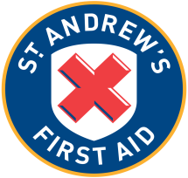](https://www.google.com/url?sa=i&rct=j&q=&esrc=s&source=images&cd=&cad=rja&uact=8&ved=2ahUKEwjCu-vNjIXcAhXEOxQKHUwaCykQjRx6BAgBEAU&url=https://en.wikipedia.org/wiki/St._Andrew's_First_Aid&psig=AOvVaw1MEXkeBBVQMbJW01jMZvJC&ust=1530781746875166)

[](https://www.google.com/url?sa=i&rct=j&q=&esrc=s&source=images&cd=&cad=rja&uact=8&ved=2ahUKEwi9lumVjIXcAhXIRhQKHdfBDnkQjRx6BAgBEAU&url=https://www.sja.org.uk/sja/what-we-do/latest-news/first-aid-for-acid-attacks.aspx&psig=AOvVaw2eanjYGH6fOD09glIAzebT&ust=1530781649228739)[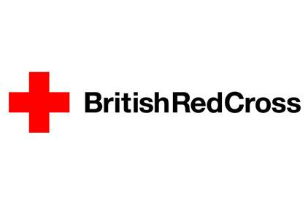](https://www.google.com/url?sa=i&rct=j&q=&esrc=s&source=images&cd=&cad=rja&uact=8&ved=2ahUKEwiihraGjIXcAhVItxQKHdUOCqAQjRx6BAgBEAU&url=https://wssagwales.wordpress.com/2014/04/10/learn-first-aid-skills-with-british-red-cross/&psig=AOvVaw1_g0HGuJHTZprExleLuvC9&ust=1530781561405145)

[](https://www.google.com/url?sa=i&rct=j&q=&esrc=s&source=images&cd=&cad=rja&uact=8&ved=&url=https://twitter.com/children1st&psig=AOvVaw3WUVop4eBdRHNTuZhbAfHU&ust=1530782101834328)

* **COACH, CLUB & VOLUNTEER:** It would be recommend to have plans to develop the coaches and volunteers at the club. Find out what support the club can offer to their coaching pathways. Good examples can include any of the following:
  + - Badminton Scotland – National Coaching Conference (Grand Prix), Club Development Workshops or Coach CPD Workshops (includes Pathway Club Workshops)
    - Sportscotland – Coach Connect or Coaching Talent Workshops
    - Local Authority – This can include any courses/workshops run/delivered by Local Authority (Council/Leisure Trust)
    - Other – submit any other types of CPD your club completes for review